Ballarat Stamp Club
April May Stamp Competition
Part 1 Scavenger Hunt
I would be very surprised if anyone was able to provide authentic examples for each category below, a print of the subject will score you 3 points and a short description will give you a bonus point. Authentic examples are worth 5 points each and a short description will give you a bonus point.
- A foil stamp
- A wooden stamp (I know paper is made from wood pulp, I won’t accept paper stamps)
- A hologram stamp
- A "scratch-and-sniff" postage stamp
- A stamp that uses thermochromic ink, to change its appearance with heat.
- A non-geometrical stamp
- A "mourning" stamp with a black border
- A stamp made from genuine tanned cod skin
- An embroidered stamp
- A Braille stamp
Total 50 points (plus any bonus points)

Part 2 Identify the bridge featured on the following stamps and its location (5 points each)
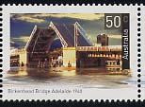
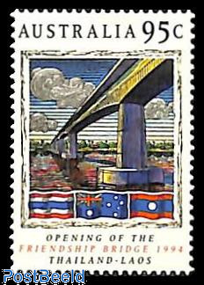
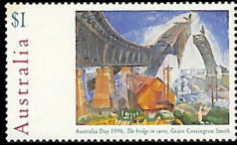

_________________ ___________________________ ______________________
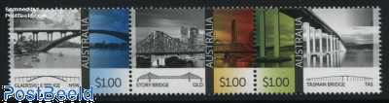
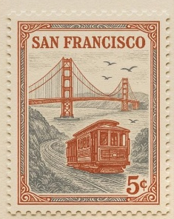

_______________ _________________ ________________ ___________________
PTO
Identify the buildings below, points allocated according to difficulty, 1 to 5 as numbered

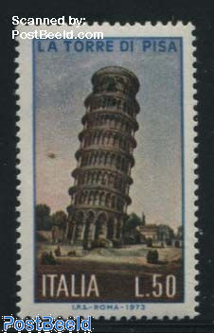

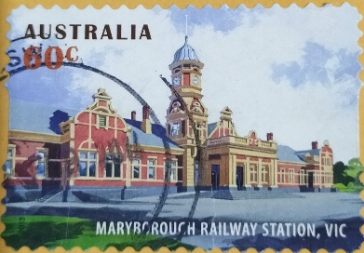
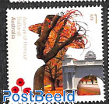

- ____________________ 2. _____________________ 3. ___________________
1 Point 2 Points 3 Points

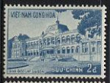
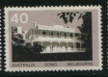

4. ______________________ 5. ______________________
4 Points 5 Points
Total Points for this section 15 points

PTO

